**Steps to Install Apache Maven:**

**Step 1**: Download the Maven Binary zip archive from this below link under Files Section. <https://maven.apache.org/download.cgi>

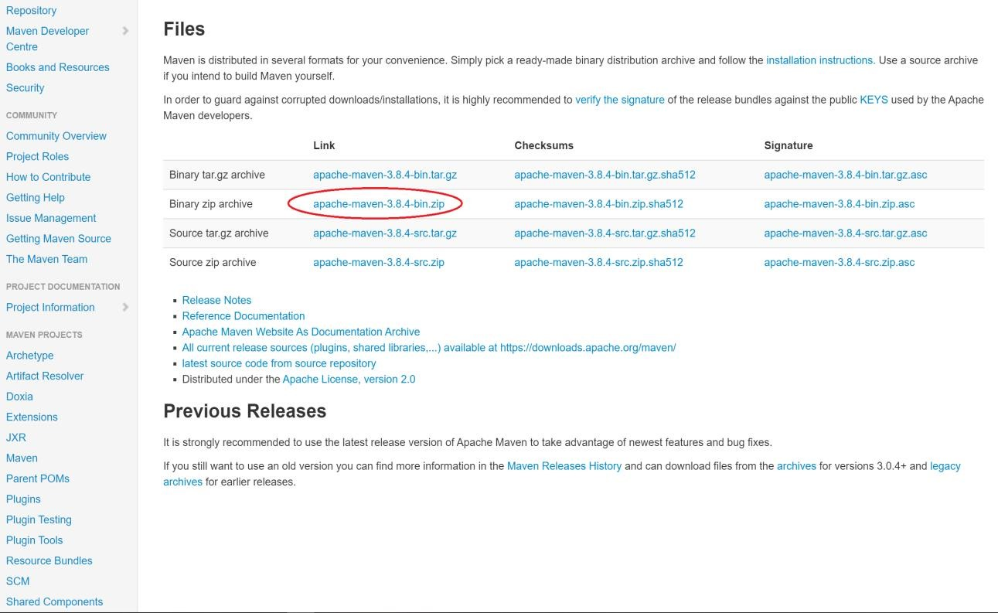

**Step 2**: Extract the downloaded zip and copy paste in any of your Drives.

**Step 3**: Open the extracted “apache-maven-3.6.0-bin” folder and go to bin folder, copy the path location

# Eg: E:\ apache-maven-3.8.4\bin

**Step 4**: Set the maven path as a environmental path variable

* Go to the below location in your machine. → Path: Control Panel\System and Security\System
* Click on “Advanced system settings” and click on Environment Variables

Add the Maven path in the Path variable under the System Variables

→ Eg: E:\apache-maven-3.8.4\bin

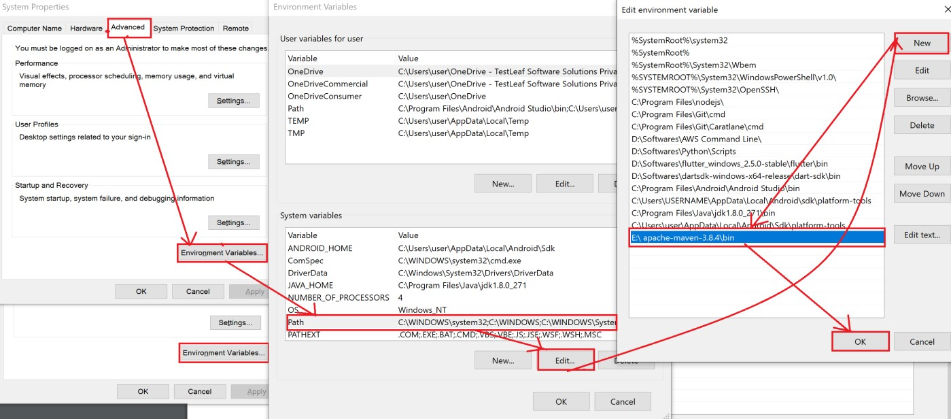

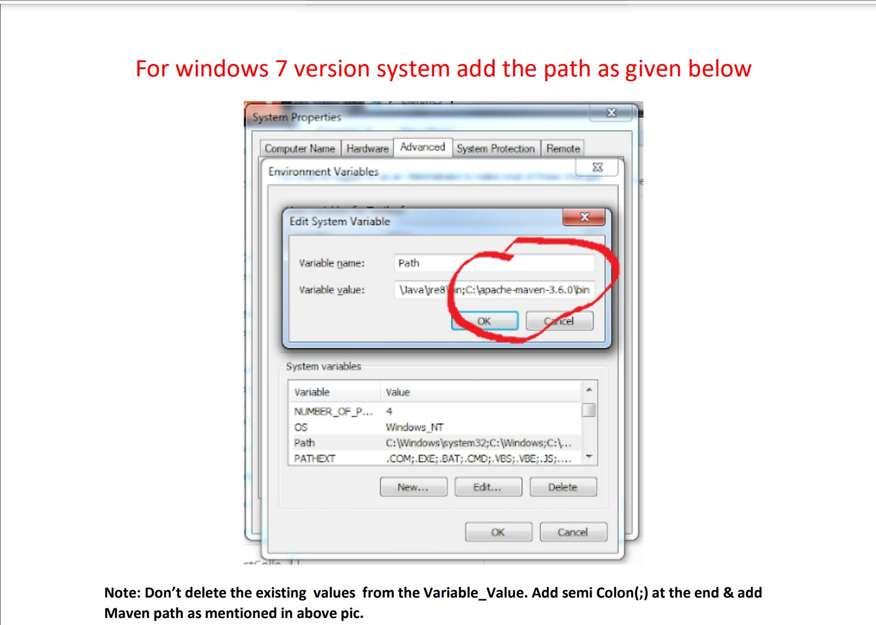

Note:The version should be entered as “E:\ apache-maven-3.8.4\bin”(latest version) in the variable value column

**Step 6**: Go to Command window and type mvn –version as a command and enter. Confirm the installation with the below reference snap.

